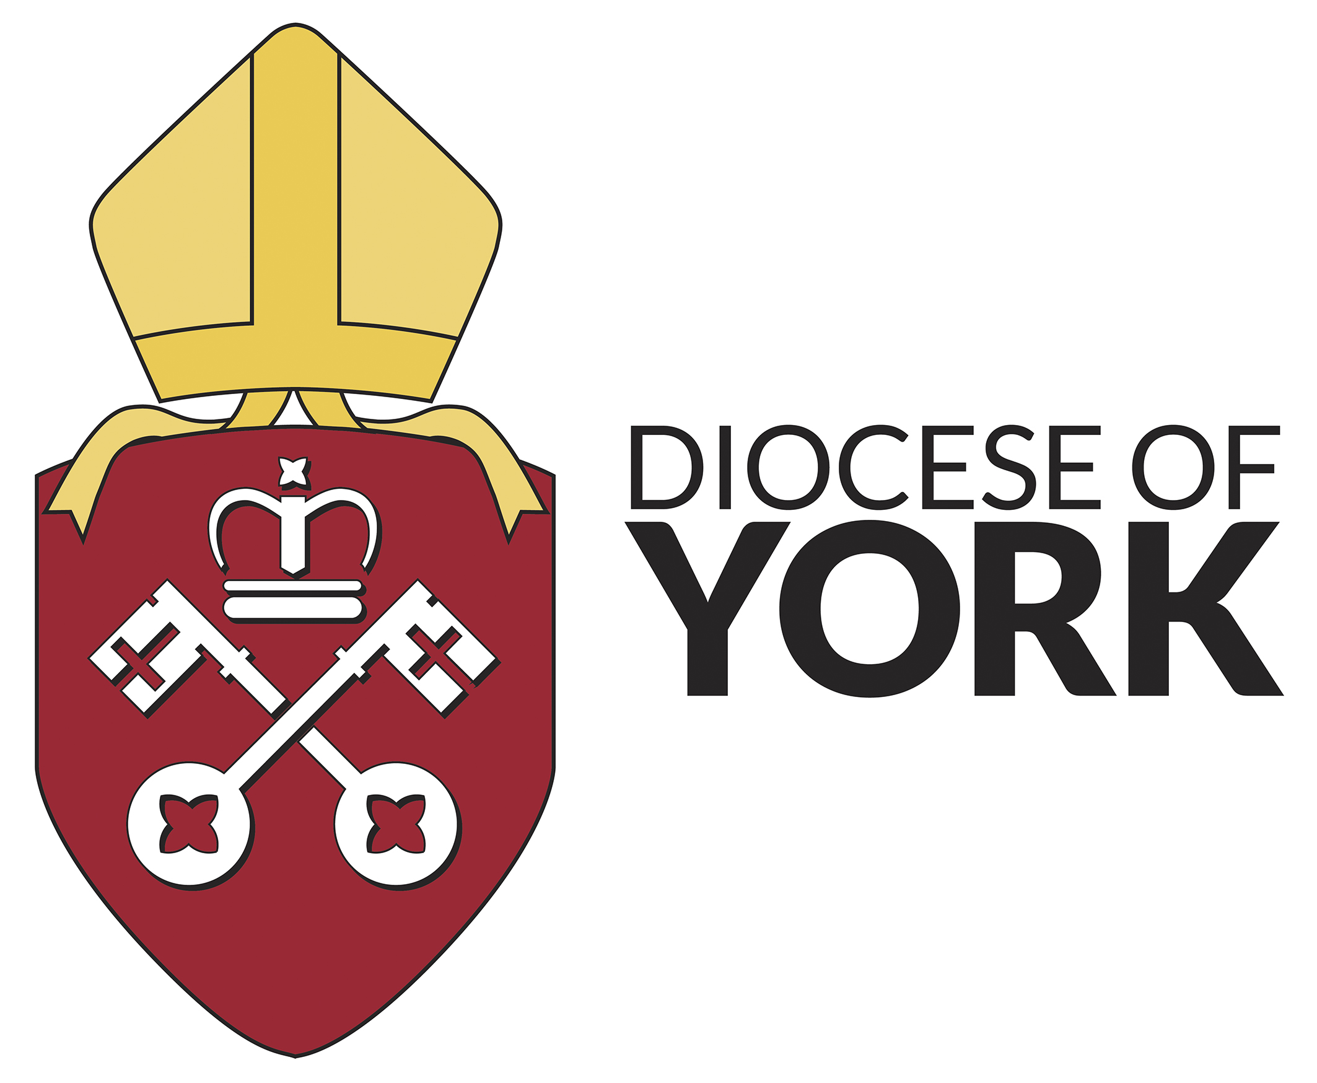

Training Team

Understanding
Me, You and Us
An Introduction to
Transactional Analysis
(Official ‘TA 101’)

With Sarah Frettingham

Thursdays, 25th January and 1st February 2018
10.00am to 5.00pm
Diocesan Office York YO30 4XT

Transactional Analysis (TA) is a model which offers understanding of human behaviour, of its development during childhood, of communication and relationships. This introductory ‘TA 101’ course will acquaint you with the main concepts of TA, including the structure of personality, transactions – the way we relate to others, time structuring, the psychological “games” we play, and life scripts.
Course participants will have the opportunity to explore their personality and relationships through the theory of TA and a range of exercises.

Who would find this useful? Those with an interest in understanding more fully their relationships with others. It has particular relevance for anyone in a pastoral role, including clergy and readers, and spiritual directors as well as people in the helping professions, counselling, management, communications or teaching.

The “TA 101” Presenter: Sarah Frettingham BA, MSc is accredited by ITAA/EATA as a Provisional Teaching and Supervising Transactional Analyst and is a UKCP Registered Psychotherapist. After gaining a Diploma in Pastoral Counselling, she worked as a counsellor in the voluntary sector and then in the NHS. She now has an independent psychotherapy, counselling and supervision practice on the border between North and East Yorkshire and in Hull, and is a churchwarden of her local church. Sarah’s passion is to see people growing in their relationship with God, and with one another, and becoming comfortable to be fully themselves. Web site www.sarahfrettingham.co.uk.

Certification: This “TA 101” course is recognised by the International Transactional Analysis Association (ITAA) and the European Association for Transactional Analysis (EATA) as their standard approved introduction to TA. Completion of the course affords participants the “TA 101” certificate, a necessary requirement for anyone wishing to enter accredited training as a TA practitioner.

Dates The “TA 101” course takes place over two days:
Thursdays 25th January and 1st February 2018 10.00am to 5.00pm
Venue: Diocesan Office Fee: £60 includes two days, workbook and refreshments – please bring your own lunch. (£30 a day for this training is less than a third of the commercial rate.)
York Diocesan clergy may claim from their CMD grant in the usual way; please book your course place with Cathy then download a CMD grant application form from the diocesan website and send to your Archdeaconry Training Adviser.
For further details contact: angela.bailey@yorkdiocese.org

---------------------------------------------------------------tear off booking form

Name ...........................................…………………………………………….

Email…………………………………………. Phone....................................

Address........................................................................................

…………………………..Any Dietary or other needs...............................

Occupation/Role ……………………………………………………………………….

I enclose a cheque for £60 payable to York DBF ….

Send booking form to: Cathy Lane, Diocese of York, Amy Johnson Way, Clifton Moor, York YO30 4XT
training@yorkdiocese.org

