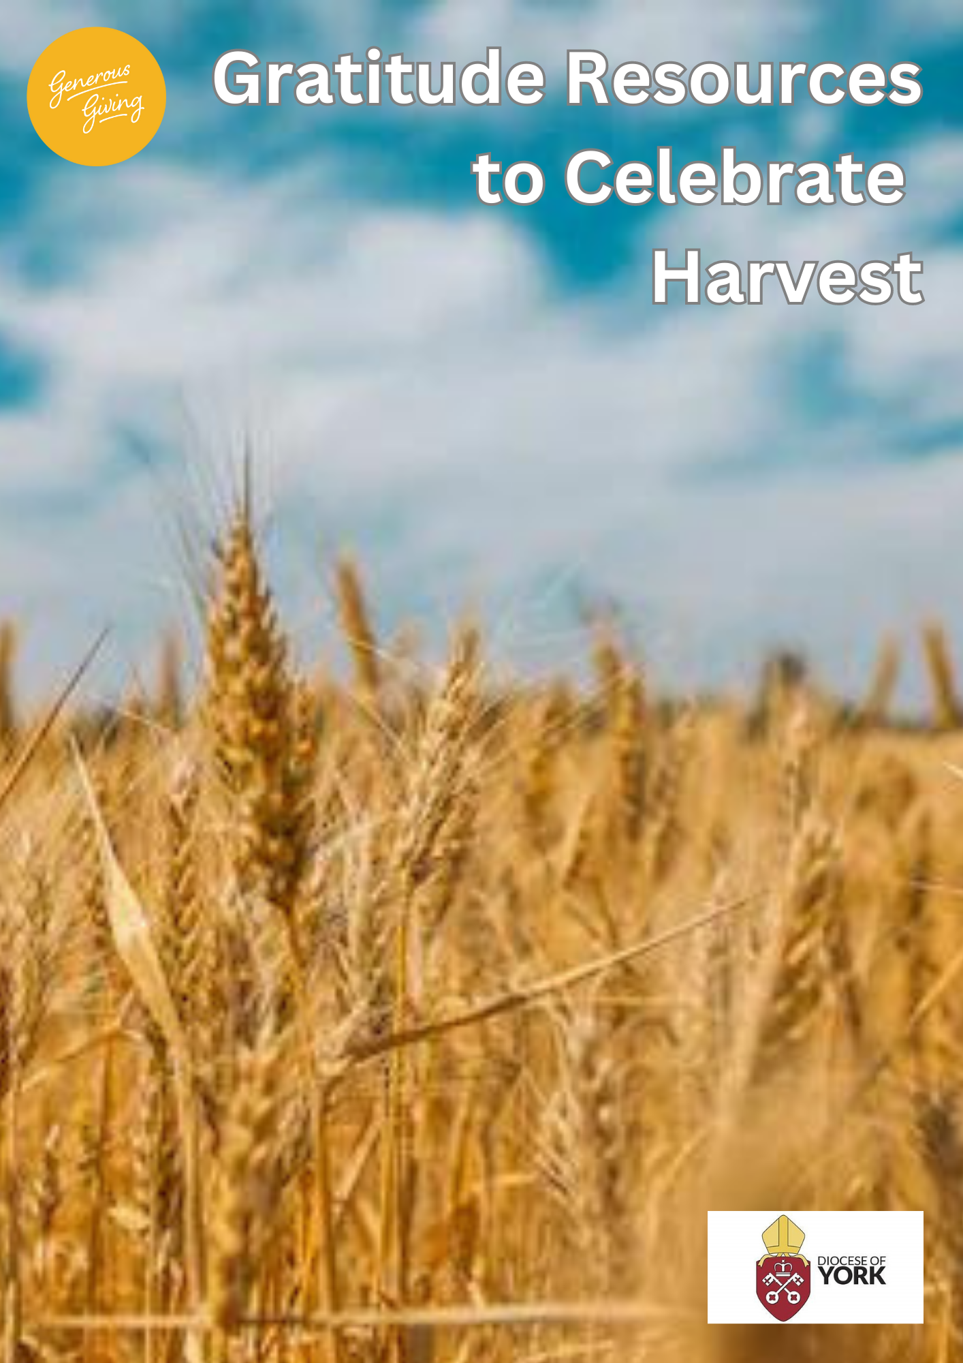
Harvest Thanksgiving Resources
Please scroll below to find:
- Sermon ideas …………………………………………………………………………………Page 2
- All age Harvest Thanksgiving ideas ……………………………………………………….Page 2
- Church of England Common Worship Harvest prayer with worship texts ………..Page 2 - 8
- Harvest Prayer Space ……………………………………………………………………….Page 8
- Young children resources, including videos of Harvest songs ………………………...Page 8
- Young People resources ……………………………………………………………………Page 9
- Songs/ Hymns for church service (A couple of possibly new harvest songs) ………..Page 9
- Harvest Bible Study booklet ………………………………………………………………...Page 9
fffffffffffffffff
- Sermon ideas

- http://www.thisischurch.com/christian_teaching/lectionary_bible_notes/lectionarybiblenotesyeara/harvestfestivalyeara.htm
- https://arthurrankcentre.org.uk/resources/harvest-2022/
fffffffffffffffffffffffffffffffffffffffffff
- All age Harvest Thanksgiving ideas

- https://www.allageworshipresources.org/harvest-food-for-the-body-and-the-soul/
- https://churchsupporthub.org/all-age-service-outline-for-harvest.php
- http://www.going4growth.com/growth_through_the_year/harvest/all_age_talks_for_harvest
- https://www.givingingrace.org/userfiles/files/Design/Harvest_all_age.pdf

fffffffffffffffffffffffffffffffffffffffffff
- Church of England Common Worship Harvest prayer and worship texts
Below is the list of what is included; each title is hyperlinked to the webpage:
Invitation to Confession
Kyrie Confessions
Confessions
Gospel Acclamation
Thanksgiving
Intercessions
Introduction to the Peace
The Bringing Forward of Symbols of the Harvest
Prayer at the Preparation of the Table
Preface
Extended Preface
Blessings and Endings
Acclamation
Short Passages of Scripture

- Invitation to Confession
Let us confess our forgetfulness of the needs of the poor and repent of the ways in which we waste the resources of the world.

- Kyrie Confessions

1) Lord, you give justice to those who are suffering and bread to those who hunger.
Lord, have mercy.
Lord, have mercy.

Lord, you loose those who are bound and open the eyes of the blind.
Christ, have mercy.
Christ, have mercy.

Lord, you watch over the stranger in the land and uphold the orphan and the widow.
Lord, have mercy.
Lord, have mercy. cf Psalm 146.6,7,9

2) God has blessed us, but still God’s children go hungry.
Lord, have mercy.
Lord, have mercy.

God has blessed us, but still the poor cry out for justice.
Christ, have mercy.
Christ, have mercy.

God has blessed us, but still we see inequality and oppression in the earth.
Lord, have mercy.
Lord, have mercy.

3) We confess to you our lack of care for the world you have given us.
Lord, have mercy.
Lord, have mercy.

We confess to you our selfishness in not sharing the earth’s bounty fairly.
Christ, have mercy.
Christ, have mercy.

We confess to you our failure to protect resources for others.
Lord, have mercy.
Lord, have mercy.

- Confessions

We confess our sin, and the sins of our society, in the misuse of God’s creation.

God our Father, we are sorry for the times when we have used your gifts carelessly and acted ungratefully.
Hear our prayer, and in your mercy:
forgive us and help us.

We enjoy the fruits of the harvest, but sometimes forget that you have given them to us.
Father, in your mercy:
forgive us and help us.
We belong to a people who are full and satisfied but ignore the cry of the hungry.
Father, in your mercy:
forgive us and help us.

We are thoughtless, and do not care enough for the world you have made.
Father, in your mercy:
forgive us and help us.

We store up goods for ourselves alone, as if there were no God and no heaven.
Father, in your mercy:
forgive us and help us.

- Gospel Acclamation
Alleluia, alleluia. Lift up your eyes and see that the fields are ripe for harvesting. Gather the fruit for eternal life.
Alleluia. cf John 4.35,36

- Thanksgiving

Let us give thanks to God, the God of all peoples of the earth.
For the colour and forms of your creation and our place within it, we bring our thanks, good Lord:
your mercy endures for ever.

For our daily food, and for those whose work and skill bring your good gifts to us, we bring our thanks,
good Lord:
your mercy endures for ever.

For the gifts and graces inspired in human minds and hearts; for insight and imagination, for the skills of research which bring healing and fulfilment to the lives of many; we bring our thanks, good Lord:
your mercy endures for ever.

For the light and shades of the changing seasons, and their variety and dependability; for new life and growth out of barrenness and decay; we bring our thanks, good Lord:
your mercy endures for ever.

For new hope and strength in our communities, especially in your Church and among all you call to serve you, we bring our thanks, good Lord;
your mercy endures for ever.

For all in whose lives we see goodness, kindness, gentleness, patience and humility, and all the fruit of the Spirit, we bring our thanks, good Lord:
your mercy endures for ever.

For the life we have been given, and for all those whom you have given us to share it, we bring our thanks, good Lord:
your mercy endures for ever.

- Intercessions

1) Let us offer our prayers to God for the life of the world and for all God’s people in their daily life and work. God, the beginning and end of all things, in your providence and care you watch unceasingly over all creation; we offer our prayers that in us and in all your people your will may be done, according to your wise and loving purpose in Christ our Lord.
Lord of all life:
hear our prayer.

We pray for all, through whom we receive sustenance and life; for farmers and agricultural workers, for packers, distributors and company boards; as you have so ordered our life that we depend upon each other, enable us by your grace to seek the well-being of others before our own.
Lord of all creation:
hear our prayer.

We pray for all engaged in research to safeguard crops against disease, and to produce abundant life among those who hunger and whose lives are at risk. Prosper the work of their hands and the searching of their minds, that their labour may be for the welfare of all.
Lord of all wisdom:
hear our prayer.

We pray for governments and aid agencies, and those areas of the world where there is disaster, drought and starvation. By the grace of your Spirit, touch our hearts and the hearts of all who live in comfortable plenty, and make us wise stewards of your gifts.
Lord of all justice:
hear our prayer.

We pray for those who are ill, remembering those in hospital and nursing homes and all who are known to us. We pray for all who care for them. Give skill and understanding to all who work for their well-being.
Lord of all compassion:
hear our prayer.

We remember those who have died, whom we entrust to your eternal love in the hope of resurrection to new life.
Lord of all peace:
hear our prayer.

We offer ourselves to your service, asking that by the Spirit at work in us others may receive a rich harvest of love and joy and peace.
Lord of all faithfulness:
hear our prayer.

God of grace, as you are ever at work in your creation, so fulfil your wise and loving purpose in us and in all for whom we pray, that with them and in all that you have made, your glory may be revealed and the whole earth give praise to you, through Jesus Christ our Lord.
Amen.

2) Let us pray to God, the Lord of the harvest, that he will bring to fruition all that he desires for his creation.
Lord of creation, we see that the fields are ripe for harvesting: we pray for your Church, that it may be ready to gather fruit for eternal life.
Lord of the harvest,
in your mercy hear us.

You have created the universe by your eternal Word and have blessed humankind in giving us dominion over the earth: we pray for the world, that we may honour and share its resources, and live in reverence for the creation and in harmony with one another.
Lord of the harvest,
in your mercy hear us.
Your Son has promised that the Spirit will lead us into all truth: we pray for the community in which you have set us, for one another and for ourselves, that we may bring forth the fruit of the Spirit in love and joy and peace.
Lord of the harvest,
in your mercy hear us.

You have given your people a rich land, yet by sin we have made a world of suffering and sorrow: we pray for those who bear the weight of affliction, that they may come to share the life of wholeness and plenty.
Lord of the harvest,
in your mercy hear us.

Your Son Jesus Christ is the first-fruits of the resurrection and will reap the harvest of the dead at the end of time: we pray that he will gather us all together with those who have gone before in the banquet of the age to come.
Lord of the harvest,
in your mercy hear us.

Source of all life and giver of all that is good, hear our prayers and grant us all that is in accordance with your will; through Jesus Christ our Lord.
Amen.

- Introduction to the Peace

The harvest of the Spirit is love, joy, peace, patience, kindness, goodness, faithfulness, gentleness and self-control. cf Galatians 5.22,23

- The Bringing Forward of Symbols of the Harvest

Let us bring forward symbols of the harvest, gifts that God has created, and his sun and rain have nurtured.
Thanks be to God.

Bring forward the harvest of the cornfields, the oats and the wheat, the rye and the barley.
Thanks be to God.

Bring forward the harvest of roots, the swedes and mangolds, turnips and sugar beet.
Thanks be to God.

Bring forward the harvest of seeds for next year’s crops, for clover, for hay and for corn.
Thanks be to God.

Bring forward the harvest of vegetables, peas, potatoes, beans and hops.
Thanks be to God.

Bring forward the harvest of pears and apples, berries and herbs.
Thanks be to God.

Bring forward the harvest of flowers, the finest blooms from our gardens and our fields.
Thanks be to God.

Bring forward the grain and the grape, for our Saviour took bread and wine to feed us with his body and his blood, given and shed for the life of the world. Let us feed on him by faith with thanksgiving.
Thanks be to God.

Praise God, from whom all blessings flow, praise him, all creatures here below, praise him above, ye heavenly host, praise Father, Son, and Holy Spirit.
Amen.

- Prayer at the Preparation of the Table

Blessed are you, Lord God of all creation; you bring forth bread from the earth.
Blessed be God for ever.

Blessed are you, Lord God of all creation; you create the fruit of the vine.
Blessed be God for ever.

- Preface

And now we give you thanks because you make us stewards of your creation, to praise you day by day for the marvels of your wisdom and power.

- Extended Preface
The Extended Prefaces for Creation and Rogation may be used (here and here).

- Blessings and Endings

1) May God our creator, who clothes the lilies and feeds the birds of the air, bestow on you his care and increase the harvest of your righteousness; and the blessing …

2) God the Father, who created the world, give you grace to be wise stewards of his creation.
Amen.

God the Son, who redeemed the world, inspire you to go out as labourers into his harvest.
Amen.

God the Holy Spirit, whose breath fills the whole of creation, help you to bear his fruits of love, joy and peace.
Amen.

And the blessing …

3) Freely you have received, freely give. Go in peace to love and serve the Lord.
in the name of Christ. Amen.

4) Tend the earth, care for God’s good creation and bring forth the fruits of righteousness.
Go in the peace of Christ.
Thanks be to God.

- Acclamation

The earth has yielded its harvest; God, our God, has blessed us.
You visit the earth and water it;

you make it very plenteous.
You soften the ground with showers;

and bless the increase of it.
You crown the year with your goodness;

and your paths overflow with plenty.
The meadows are clothed with sheep;

the valleys stand so thick with corn, they shout for joy and sing.
The earth has yielded its harvest; God, our God, has blessed us.
cf Psalm 65.8,10,11,13; 67.7

- Short Passages of Scripture
1) Then shall the earth bring forth her increase, and God, our own God, will bless us. Psalm 67.6
2) O give thanks to the Lord, for he is gracious, for his steadfast love endures for ever. Psalm 107.1
3) As long as the earth endures, seedtime and harvest, cold and heat, summer and winter, day and night shall not cease. Genesis 8.22
4) He who supplies seed to the sower and bread for food will supply and multiply your seed for sowing and increase the harvest of your righteousness. 2 Corinthians 9.10
5) The harvest is plentiful, but the labourers are few; therefore, ask the Lord of the harvest to send out labourers into his harvest. Matthew 9.37b,38

fffffffffffffffffffffffffffffffffffffffffff
- Harvest Prayer Space

- Generosity in creative prayer: Harvest (d3hgrlq6yacptf.cloudfront.net)

fffffffffffffffffffffffffffffffffffffffffff
- Young children resources

- Harvest - BBC Teach - Themes: Gratitude; thankfulness; the annual harvest; understanding where food comes from.
Summary: The video starts with two boys describing the farm they live on in Cambridgeshire and some of the food they grow there. They talk about the harvest and all the work that is done on the farm during that time. They are joined by other children who then consider the questions: What’s your favourite food? Where does your food come from? What sort of things do farmers in the UK grow? Why is it important to know where your food comes from? Why is Harvest Festival important?
harvest_bbc_teach.pdf (bbci.co.uk) The overview planning can be tweaked to make it fit with your church setting, but it’s really helpful for children to appreciate farmers and where their food comes from.
- https://www.messychurch.org.uk/tags/harvest - ideas for an interactive Harvest for young ones.
- https://www.eparenting.co.uk/activities_for_kids/harvest_festival_activities_for_kids.php - 17 craft ideas.

- Songs for young children with video and words:

- https://www.youtube.com/watch?v=27A9sdoY91w – Thank You God for the Harvest with Makaton signing.
- https://www.youtube.com/watch?v=dqpkWsR6Yew - Harvest Samba (Cabbages and Greens)

fffffffffffffffffffffffffffffffffffffffffff

- Youth resources

- https://www.wateraid.org/uk/publications/harvest-2019-youth-activity-for-community-groups - to engage the young people in knowing how clean water is vital for a good harvest. Social action could be encouraged.
- https://www.chelmsford.anglican.org/uploads/files/Harvest.pdf - a Harvest booklet produced by the Diocese of Chelmsford. Pages 12 and 13 have ideas for young people.

fffffffffffffffffffffffffffffffffffffffffff

- Songs/ Hymns for church service
Along with the traditional harvest hymns of ‘We plough the fields and scatter’ and ‘Come ye thankful people’, here are a couple you may wish to try:
- https://www.youtube.com/watch?v=8JB7R2RokaY - A Harvest of Thanksgiving (With Lyrics)
- https://www.youtube.com/watch?v=PMpM65Ez2hc - We see the fruitful harvest (With Lyrics)

fffffffffffffffffffffffffffffffffffffffffff
Harvest Bible Study
https://dioceseofyork.org.uk/uploads/attachment/6061/the-harvest-is-plentiful.pdf

Acknowledgements:
We are grateful to the Church of England for allowing us to use their resources in this pack.
Material from Common Worship: Times and Seasons included here is copyright The Archbishops’ Council 2006 and is used with permission.
This pack was put together by the Diocese of York Generous Giving team.
www.dioceseofyork.org.uk/generosity

