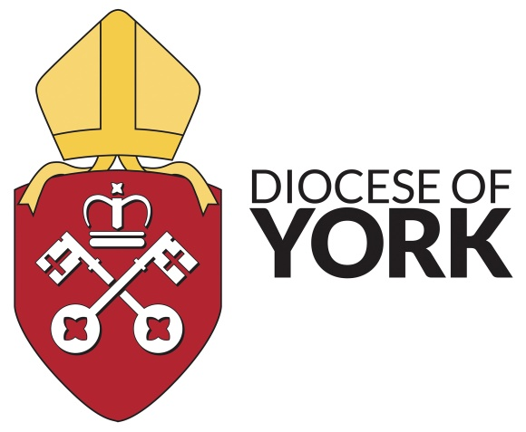

**Pastoral and Counselling Support for Clergy and Diocesan Staff** During the interim period between Andrew De Smet retiring at the end of April and a new Pastoral Care Adviser being appointed.

Andrew De Smet and Elizabeth Harland will do **counselling referrals** and some counselling themselves so contact either of them:

**Andrew**: andrewdesmet@btinternet.com, 07583279459

**Elizabeth Harland**: elizabeth_harland@hotmail.co.uk, 07855074594

Andrew will still be available for **one off conversations/pastoral supervision** during the interim.

Mark Rance at Wydale is a qualified **Mediator**.

**Diocesan Anti-bullying policy**

The Diocese of York has adopted a Policy on Bullying and Harassment to encourage behaviours and practices to eliminate both harassment and bullying from relationships and interactions in parishes and within the diocesan administration. Find the policy here: [Bullying and Harassment policy](https://dioceseofyork-my.sharepoint.com/personal/louise_dover_yorkdiocese_org/Documents/Downloads/dioceseofyork.org.uk/wp-content/uploads/2024/08/doy-bullying-amp-harassment-policy-2022-1.pdf).

**Debt & Financial Hardship**

The York Diocesan Ministers’ Relief Fund seeks to relieve need, hardship and distress for clergy persons or licenced lay workers who serve or reside (or have served or resided) in the Diocese of York, and their dependant relatives or those who have acted as housekeepers. The Ministers Relief Fund (MRF) gives grants, and occasionally small loans, to relieve financial need, hardship or distress. It doesn’t matter why this has come about, whether it’s through illness, accident, or if problems have building up over a longer period. To apply for a grant, you can download the form from: [dioceseofyork.org.uk/mrf](https://dioceseofyork.org.uk/mrf) and send it to your Archdeacon or Kathryn Rose (Clerk to the Trustees).

You can contact Kathryn at the Diocesan Office on 01904 699500 or email: kathryn.rose@yorkdiocese.org. Any application or call will be treated with complete confidence. Archdeacons can provide advice. Referral for confidential debt counselling is also available.

The Clergy Support Trust is also worth approaching [www.clergysupport.org.uk](http://www.clergysupport.org.uk).

**Spiritual Direction**:

York: **Barbara Martin**: [barmart51@hotmail.com](mailto:barmart51@hotmail.com)

Cleveland: **Margaret Cooper**: [mlcooper8102@gmail.com](mailto:mlcooper8102@gmail.com), 07443613949

East Riding: **The Revd Andrew De Smet**: [andrewdesmet@btinternet.com](mailto:andrewdesmet@btinternet.com), 07583279459