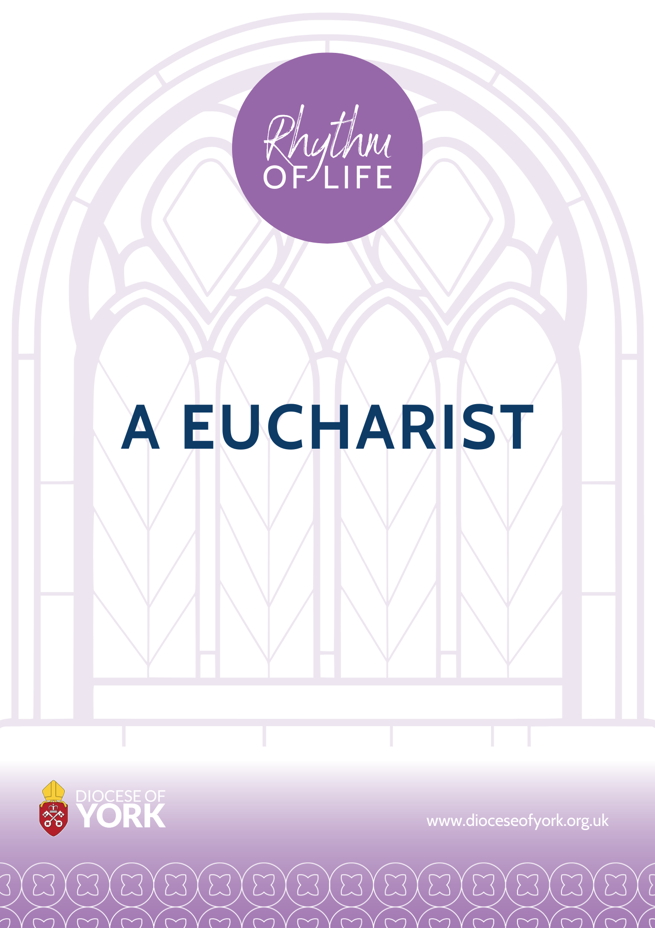

Rhythm of Life: The Eucharist
Liturgical Notes

Being (life) in the vine has been the guiding theme for preparing this liturgical material for a eucharistic celebration in the parish. The biblical text in the background here is John 15.1-17, with a focus on Jesus as the centre and, by this, on community, service, and witness.

The gathering on a Sunday morning has been first considered, as this is when, in most cases, the largest worshipping community gathers. The service material here would also suit a Quiet Day (or similar) when a parish group are spending time together in prayer and study on an aspect of Rhythm of Life. An assumption has been made that this service of Holy Communion will be celebrated in the season of Ordinary Time, enabling a deeper focus on discipleship and witness in Christian life and community.

John 15.1-17 features as the Sunday Gospel reading for the Fifth and Sixth Sunday of Easter (Year B). The setting of Easter is an appropriate lens to approach and consider ‘being in the vine.’ Looking at the Bible readings for those two Sundays offers very fitting choices for a eucharistic celebration themed towards the reflection and celebration of having a ‘rhythm of life’ (as this is principally founded on Jesus’ rhythm and what he instructs us to do). As well as Bible readings for these two Sundays, you might find it helpful to also look at hymns and music options for the Fifth and Sixth Sunday of Easter.

As well as liturgical material set for the Fifth and Sixth Sunday of Easter, material from Times and Seasons, All Saints to Advent, has also been included. Here there is a particular emphasis on ‘community’ and a ‘looking to the kingdom to come,’ which fit well with the Rhythm of Life wider worship resources and the overall project. Other reference points in Scripture explored: Matthew 6.33, with a focus on first striving for the kingdom; Ephesians 3.17 that we are to be rooted and grounded in love
John 1.1-3 ‘What has come into being in him was life, and the life was the light of all people’ – with Christ as the centre made clear. John 15.9 As the Father has loved me, I have loved you: abide in my love - with a focus on Jesus’ command to us that we ‘abide’ in him and his love.

In summary
The eucharistic material offered here looks to the John 15.1-17 reading and considers themes from All Saints to Advent around community and the kingdom. These seem to connect well with the Rhythm of Life material. An element of the diocesan Rhythm of Life material could be further explored in the Sermon, and the Introduction (though brief) could be suitably used to focus the worshipping community’s attention on a particular aspect for reflection (praise and celebration) in the service.

Lectionary readings for Fifth and Sixth Sunday of Easter Year B:
Given that the service here is to take place during Ordinary Time (or, at least, not in the Easter Season), other readings than the Acts reading can be used.

Fifth Sunday of Easter
Gen. 22.1-18
Ps. 22.25-end
1 John 4.7-end
John 15.1-8
Sixth Sunday of Easter
Isa. 55.1-11
Ps.98
1 John 5.1-6
John 15.9-17

The Gathering

At the entry of the ministers a hymn may be sung.

The president may say
In the name of the Father,
and of the Son,
and of the Holy Spirit.
All Amen.

The Greeting
The president greets the people

The Lord be with you
All and also with you.

Welcome to our service of Holy Communion. We gather today to meet the risen Lord in both Word and Sacrament. We are reminded always of God’s goodness and we come to give him our thanks and praise. Called to live our lives in and for Christ; he is vine and we are the branches. We abide together with Christ and we are blessed, bringing forth much fruit, to the Father’s glory, and for his kingdom now, and, in the time to come.

Prayer of Preparation
This prayer may be said

All Almighty God,
to whom all hearts are open,
all desires known,
and from whom no secrets are hidden:
cleanse the thoughts of our hearts
by the inspiration of your Holy Spirit,
that we may perfectly love you,
and worthily magnify your holy name;
through Christ our Lord.
Amen.

or

Let everything be said and done in the name of the Lord Jesus,
giving thanks to God through Jesus Christ.

Sing psalms, hymns and sacred songs:
let us sing to God with thankful hearts.

Open our lips, Lord:
and we shall praise your name. (see Colossians 3.16)

Prayers of Penitence

A minister uses these or other suitable words
Let us confess to God the sins and shortcomings of the world;
its pride, its selfishness, its greed;
its evil distortions and hatreds.
Let us confess our share in what is wrong,
and our failure to seek and establish that peace
which God wills for all his children.
(CW Times and Seasons All Saints to Advent)

All Almighty God, our heavenly Father,
we have sinned against you
and against our neighbour
in thought and word and deed,
through negligence, through weakness,
through our own deliberate fault.
We are truly sorry
and repent of all our sins.
For the sake of your Son Jesus Christ,
who died for us,
forgive us all that is past
and grant that we may serve you in newness of life
to the glory of your name.
Amen.

The president says

Almighty God,
who forgives all who truly repent,
have mercy upon you,
pardon and deliver you from all your sins,
confirm and strengthen you in all goodness,
and keep you in life eternal;
through Jesus Christ our Lord.
All Amen.

Gloria in Excelsis
The Gloria in excelsis may be used

All Glory to God in the highest,
and peace to his people on earth.
Lord God, heavenly King,
almighty God and Father,
we worship you, we give you thanks,
we praise you for your glory.
Lord Jesus Christ, only Son of the Father,
Lord God, Lamb of God,
you take away the sin of the world:
have mercy on us;
you are seated at the right hand of the Father:
receive our prayer.
For you alone are the Holy One,
you alone are the Lord,
you alone are the Most High, Jesus Christ,
with the Holy Spirit,
in the glory of God the Father.
Amen.

or, sung to hymn tune: Guide me O thou great redeemer
Glory be to God in heaven,
songs of joy and peace we bring,
thankful hearts and voices raising,
to creation's Lord we sing:
Lord we thank you, Lord we bless you,
glory be to God our King,
glory be to God our King.

Lamb of God, who on your shoulders
bore the load of this world's sin,
only Son of God the Father,
you have brought us peace within:
Lord, have mercy, Christ have mercy,
now your glorious reign begin,
now your glorious reign begin.

You, O Son of God are holy,
you we praise with one accord;
none in heav'n or earth is like you,
only you are Christ the Lord -
with the Father and the Spirit,
ever worshipped and adored,
ever worshipped and adored.

The Collect
The president introduces a period of silent prayer with the words ‘Let us pray’ or a more specific bidding.

God our redeemer,
you have delivered us from the power of darkness
and brought us into the kingdom of your Son:
grant, that as by his death he has recalled us to life,
so by his continual presence in us he may raise us to eternal joy;
through Jesus Christ your Son our Lord,
who is alive and reigns with you in the unity of the Holy Spirit,
one God, now and for ever. Amen. (Collect for the Sixth Sunday of Easter)

or

Risen Christ,
by the lakeside you renewed your call to your disciples:
help your Church to obey your command,
and draw the nations to the fire of your love,
to the glory of God the Father.
Amen. (CW Additional Collects)

The Liturgy of the Word

Readings
Either one or two readings from Scripture precede the Gospel reading.
At the end of each the reader may say
This is the word of the Lord.
All Thanks be to God.

The psalm or canticle follows the first reading; other hymns and songs may be used between the readings.

Gospel Reading
An acclamation may herald the Gospel reading.

Alleluia! Alleluia!
You did not choose me but I chose you, says the Lord,
And I appointed you to go and bear fruit, fruit that will last.
Alleluia!

When the Gospel is announced the reader says
Hear the Gospel of our Lord Jesus Christ according to N.
All Glory to you, O Lord.

At the end
This is the Gospel of the Lord.
All Praise to you, O Christ.

Sermon the sermon could take as its focus one of the seven practices of Rhythm of Life and consider this in the context of the Gospel reading from John OR one of the Reflections written by the bishops could be read out or used in some way here. If a more interactive approach is sought, then the questions from the Toolkit for Churches on each of the seven practices could be used.

The Creed
On Sundays and Principal Holy Days an authorized translation of the Nicene Creed is used, or, on occasion, the Apostles’ Creed or an authorized Affirmation of Faith may be used.

Let us declare our faith in God, Father, Son and Holy Spirit

All We believe in one God,
the Father, the Almighty,
maker of heaven and earth,
of all that is,
seen and unseen.
We believe in one Lord, Jesus Christ,
the only Son of God,
eternally begotten of the Father,
God from God, Light from Light,
true God from true God,
begotten, not made,
of one Being with the Father;
through him all things were made.
For us and for our salvation he came down from heaven,
was incarnate from the Holy Spirit and the Virgin Mary
and was made man.
For our sake he was crucified under Pontius Pilate;
he suffered death and was buried.
On the third day he rose again
in accordance with the Scriptures;
he ascended into heaven
and is seated at the right hand of the Father.
He will come again in glory to judge the living and the dead,
and his kingdom will have no end.
We believe in the Holy Spirit,
the Lord, the giver of life,
who proceeds from the Father and the Son,
who with the Father and the Son is worshipped and glorified,
who has spoken through the prophets.
We believe in one holy catholic and apostolic Church.
We acknowledge one baptism for the forgiveness of sins.
We look for the resurrection of the dead,
and the life of the world to come.
Amen.

or the following may be used

Affirmation of Faith
Let us declare our faith in God.

Do you believe and trust in God the Father,
source of all being and life,
the one for whom we exist?
We believe and trust in him.

Do you believe and trust in God the Son,
who took our human nature,
died for us and rose again?
We believe and trust in him.

Do you believe and trust in God the Holy Spirit,
who gives life to the people of God
and makes Christ known in the world?
We believe and trust in him.

This is the faith of the Church.
This is our faith
We believe and trust in one God
Father, Son, and Holy Spirit. Amen.

Prayers of Intercession
Jesus our exalted Lord has been given all authority.
Let us seek his intercession, that our prayers may be perfected by his prayer.

Jesus Christ, great high priest, living for ever to intercede for us:
pray for your Church, your broken body in the world …
Lord, hear us.
Lord, graciously hear us.

Jesus Christ, King of righteousness,
enthroned at the right hand of the majesty on high:
pray for the world, and make it subject to your gentle rule …
Lord, hear us.
Lord, graciously hear us.

Jesus Christ, Son of man, drawing humanity into the life of God:
pray for your brothers and sisters in need, distress or sorrow …
Lord, hear us.
Lord, graciously hear us.

Jesus Christ, pioneer of our salvation,
bringing us to your glory through your death and resurrection:
pray for all who are dying, that they may trust in your promises …
Lord, hear us.
Lord, graciously hear us.

Jesus Christ, Lord of all things,
ascended far above from the heavens and filling the universe:
pray for us who receive the gifts you give us for
work in your service …
Lord, hear us.
Lord, graciously hear us.

Jesus Christ, first-fruits of the new creation,
keep the Church in the unity of the Spirit
and in the bond of peace,
until you bring the whole created order to worship at your feet;
for you are alive and reign with the Father and the Holy Spirit,
one God, now and for ever.
Amen. (CW Times and Seasons All Saints to Advent H2)

The Liturgy of the Sacrament ↑

The Peace
The president may introduce the Peace with a suitable sentence

Jesus says ‘abide in me as I abide in you. I am the vine, you are the branches. Those who abide in me and I in them bear much fruit, because apart from me you can do nothing.’
(see John 15.4-5)
The peace of the Lord be always with you
All and also with you.

These words may be added
Let us offer one another a sign of peace.
All may exchange a sign of peace.

Preparation of the Table
Taking of the Bread and Wine
A hymn may be sung.
The gifts of the people may be gathered and presented.
The table is prepared and bread and wine are placed upon it.
One or more of the prayers at the preparation of the table may be said.
The president takes the bread and wine.

Prayer at the Preparation of the Table
The President may say
Gracious God,
you show us your way and give us your divine life:
may everything we do be directed
by the knowledge of your truth;
we ask this in the name of Jesus Christ our risen Lord.
Amen. (Enriching the Liturgy, Fifth Sunday of Easter)

The Eucharistic Prayer
The president says
The Lord be with you
All and also with you.
Lift up your hearts.
All We lift them to the Lord.
Let us give thanks to the Lord our God.
All It is right to give thanks and praise.

The president praises God for his mighty acts

(Extended Preface CW Times and Seasons, All Saints to Advent)
It is indeed right, our duty and our joy,
that we should always sing of your glory,
holy Father, almighty and eternal God,
through Jesus Christ your Son our Lord.
For you are the hope of the nations,
the builder of the city that is to come.
Your love made visible in Jesus Christ
brings home the lost,
restores the sinner
and gives dignity to the despised.
In his face your light shines out,
flooding lives with goodness and truth,
gathering into one in your kingdom
a divided and broken humanity.
Therefore with all who can give voice in your creation
we glorify your name, for ever praising you and saying:

All Holy, holy, holy Lord,
God of power and might,
heaven and earth are full of your glory.
Hosanna in the highest.
[Blessed is he who comes in the name of the Lord.
Hosanna in the highest.]

The president recalls the Last Supper

We praise and bless you, loving Father,
through Jesus Christ, our Lord;
and as we obey his command,
send your Holy Spirit,
that broken bread and wine outpoured
may be for us the body and blood of your dear Son.

On the night before he died he had supper with his friends
and, taking bread, he praised you.
He broke the bread, gave it to them and said:
Take, eat; this is my body which is given for you;
do this in remembrance of me.

When supper was ended he took the cup of wine.
Again he praised you, gave it to them and said:
Drink this, all of you;
this is my blood of the new covenant,
which is shed for you and for many for the forgiveness of sins.
Do this, as often as you drink it, in remembrance of me.

So, Father, we remember all that Jesus did,
in him we plead with confidence his sacrifice
made once for all upon the cross.
Bringing before you the bread of life and cup of salvation,
we proclaim his death and resurrection
until he comes in glory.

The following acclamation may be used

Praise to you, Lord Jesus:
All Dying you destroyed our death,
rising you restored our life:
Lord Jesus, come in glory.

The Prayer continues and leads into the doxology,

Lord of all life,
help us to work together for that day
when your kingdom comes
and justice and mercy will be seen in all the earth.
Look with favour on your people,
gather us in your loving arms
and bring us with Mary, mother of our Lord, and all the saints
to feast at your table in heaven.
Through Christ, and with Christ, and in Christ,
in the unity of the Holy Spirit,
all honour and glory are yours, O loving Father,
for ever and ever.
all respond boldly
All Amen.

The Lord’s Prayer
As our Saviour taught us, so we pray
All Our Father in heaven,
hallowed be your name,
your kingdom come,
your will be done,
on earth as in heaven.
Give us today our daily bread.
Forgive us our sins
as we forgive those who sin against us.
Lead us not into temptation
but deliver us from evil.
For the kingdom, the power,
and the glory are yours
now and for ever.
Amen.

(or)

Let us pray with confidence as our Saviour has taught us
All Our Father, who art in heaven,
hallowed be thy name;
thy kingdom come;
thy will be done;
on earth as it is in heaven.
Give us this day our daily bread.
And forgive us our trespasses,
as we forgive those who trespass against us.
And lead us not into temptation;
but deliver us from evil.
For thine is the kingdom,
the power and the glory,
for ever and ever.
Amen.

Breaking of the Bread
The president breaks the consecrated bread.
We break this bread
to share in the body of Christ.
All Though we are many, we are one body,
because we all share in one bread.

The Agnus Dei may be used as the bread is broken
All Lamb of God,
you take away the sin of the world,
have mercy on us.
Lamb of God,
you take away the sin of the world,
have mercy on us.
Lamb of God,
you take away the sin of the world,
grant us peace.

(or)

All Jesus, Lamb of God,
have mercy on us.
Jesus, bearer of our sins,
have mercy on us.
Jesus, redeemer of the world,
grant us peace.

Giving of Communion
The president says an invitation to communion
Jesus is the Lamb of God
who takes away the sin of the world.
Blessed are those who are called to his supper.
All Lord, I am not worthy to receive you,
but only say the word, and I shall be healed.

One of these prayers may be said before the distribution
All We do not presume
to come to this your table, merciful Lord,
trusting in our own righteousness,
but in your manifold and great mercies.
We are not worthy
so much as to gather up the crumbs under your table.
But you are the same Lord
whose nature is always to have mercy.
Grant us therefore, gracious Lord,
so to eat the flesh of your dear Son Jesus Christ
and to drink his blood,
that our sinful bodies may be made clean by his body
and our souls washed through his most precious blood,
and that we may evermore dwell in him, and he in us.
Amen.

(or)
All Most merciful Lord,
your love compels us to come in.
Our hands were unclean,
our hearts were unprepared;
we were not fit
even to eat the crumbs from under your table.
But you, Lord, are the God of our salvation,
and share your bread with sinners.
So cleanse and feed us
with the precious body and blood of your Son,
that he may live in us and we in him;
and that we, with the whole company of Christ,
may sit and eat in your kingdom.
Amen.
The president and people receive communion.
Authorized words of distribution are used and the communicant replies
Amen.

During the distribution hymns and anthems may be sung.

Prayer after Communion

Silence is kept.
The Post Communion or another suitable prayer is said.

Eternal God,
whose Son Jesus Christ is the way, the truth, and the life:
grant us to walk in his way,
to rejoice in his truth,
and to share his risen life;
who is alive and reigns, now and for ever.
Amen. (CW Main Volume Post Communion Prayer, Fifth Sunday of Easter)

All may say one of these prayers
All Almighty God,
we thank you for feeding us
with the body and blood of your Son Jesus Christ.
Through him we offer you our souls and bodies
to be a living sacrifice.
Send us out
in the power of your Spirit
to live and work
to your praise and glory.
Amen.

(or)

All Father of all,
we give you thanks and praise,
that when we were still far off
you met us in your Son and brought us home.
Dying and living, he declared your love,
gave us grace, and opened the gate of glory.
May we who share Christ’s body live his risen life;
we who drink his cup bring life to others;
we whom the Spirit lights give light to the world.
Keep us firm in the hope you have set before us,
so we and all your children shall be free,
and the whole earth live to praise your name;
through Christ our Lord.
Amen.

The Dismissal ↑
A hymn may be sung.

The president may use a seasonal blessing, or another suitable blessing

(or)

The peace of God,
which passes all understanding,
keep your hearts and minds
in the knowledge and love of God,
and of his Son Jesus Christ our Lord;
and the blessing of God almighty,
the Father, the Son, and the Holy Spirit,
be among you and remain with you always.
All Amen.

A minister says
Go in peace to love and serve the Lord.
All In the name of Christ. Amen.

(or)

Go in the peace of Christ.
All Thanks be to God.

The ministers and people depart.

Material in this Order of Service is reproduced from Common Worship: Services and Prayers for the Church of England (2000), copyright © The Archbishops’ Council of the Church of England, 2000. This compilation is copyright © 2024 York Diocesan Board of Finance Ltd. Amy Johnson Way, York, YO30 4XT. Company limited no. 225234. Registered charity no. 244976.

