Template for a statement of needs

Please use this template in conjunction with the guidance released on the Church of England website
https://www.churchofengland.org/resources/churchcare/advice-and-guidance-church-buildings/statements-significance-and-needs
To complete this template, please enter text in the white spaces provided below each grey box, starting where the “Enter Text Here” is highlighted. This text will need to be removed when editing these sections. The pages in this document will expand as you write, and the grey boxes should always appear at the top of a new page.
The template was last issued in May 2025 by the Cathedral and Church Buildings Department, Church Commissioners and has been produced under the remit of the Church Buildings Council pursuant to its powers under section 55(1)(d) of the Dioceses, Mission and Pastoral Measure 2007.

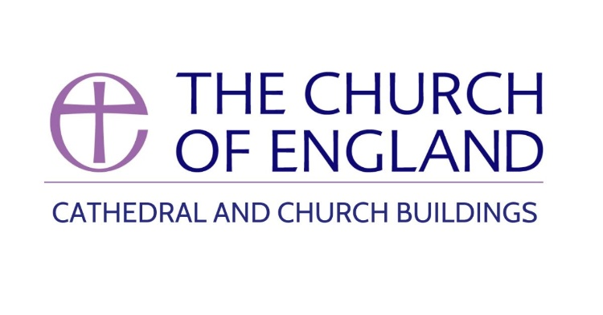

What are the needs?
Here, talk about the reasons for seeking improvement, not the proposal.
- Why are people seeking improvement?
- What problems would be addressed by the proposals?
- Remember to be specific and people-based.
Make sure this includes information for someone who does not know your parish. For example:
- How is your building currently used for worship or community purposes?
- How many people live in the parish/ village/ town?
- How many people are on the electoral roll?
- What different types of services take place in the church each week/ month and how many people attend each of the different services on average?
- What is the age profile of the congregation? What provision for children is there? How many children attend these activities?
- Are there are any plans for the development of housing in the parish or nearby?
- Is the church normally left open during daylight hours?
You can find a one page summary of attendance, census and deprivation information for your parish via the online parish returns system. These are useful facts that can support your application.

Enter Text Here

What is the evidence for the need?

- How can you demonstrate to the decision maker that there is a strong rationale for this change?
- Is the work recommended in the Quinquennial Inspection report?
- Has change in the congregation or community created a new need?
- Are facilities lacking in the church or community?
- Does this give you an opportunity to expand current activities or worship styles held in the church?
- Have you done an accessibility audit?
- Have you completed or undertaken any of the following to support the proposal:
- the Energy Footprint Tool (on the Online Parish Returns system)
- the Practical Path to Net-Zero
- a heating checklist
- an energy audit / decarbonisation action plan
- registration, an award, or working toward an award with Eco Church (an A Rocha UK project)?
- Have you done any consultation or surveys? Have you spoken to people in the church and community? Have you received any letters of support?

Enter Text Here

Describe the proposals

Include enough detail so that, alongside any drawings, your proposals are clear to someone who does not know the building.
- What are the changes?
- Where are the changes?
- How do the changes impact accessibility, including lighting, sound, circulation spaces and locations for activities?
- Is there any professional supervision?

Enter Text Here

What other options have been considered? Why have you chosen the proposed option and discounted others?

- What is the evidence that this is the best solution to meet the needs?
- Were alternative locations considered?
- Were alternative materials or designs considered?
- Is this the best option for accessibility, including consideration of lighting, sound, circulation spaces and locations for activities? If not, why has it been chosen?
- You can upload a separate options appraisal for more complex projects

Enter Text Here

Why should the proposed changes be made now?

- Are there urgent issues with the condition of the building or contents?
- Is there financial or human resource available?

Enter Text Here

How would your proposal help the worship and mission of your church?

- Would it have liturgical benefit?
- Would it allow a different style of worship?
- Would it improve welcome?
- Would it support outreach or invite more people into the church?
- Would it improve accessibility – including lighting, sound, circulation spaces or location for activities?

Enter Text Here

How does your project contribute to environmental sustainability?

- Does the proposal increase biodiversity?
- Does the proposal safeguard wildlife or protected species?
- Does the proposal improve the energy efficiency of the building?
- Does the proposal reduce the carbon footprint of the church?
- How will the proposal minimise waste?
- Can any of materials be reused or recycled within the project or by others?

Enter Text Here

