Farewill Step-by-Step Guide

- Visit https://farewill.com/diocese-of-york and click the ‘Get started' button.

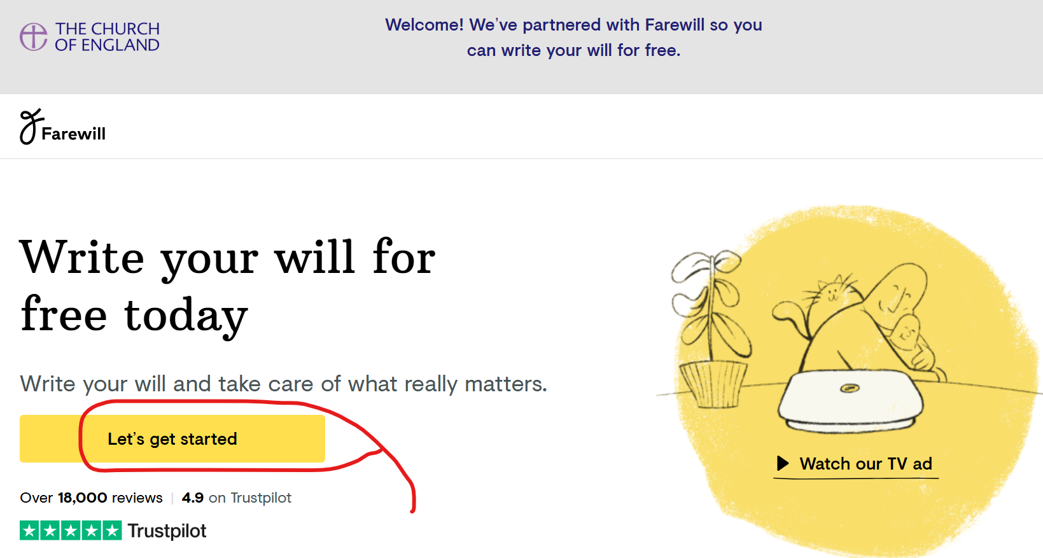
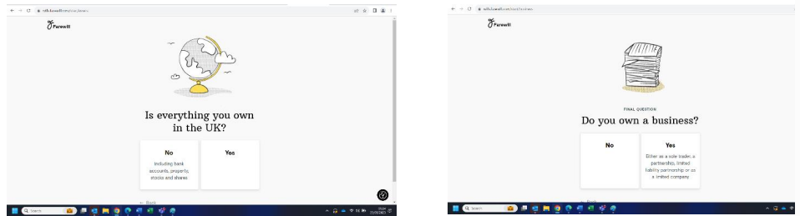
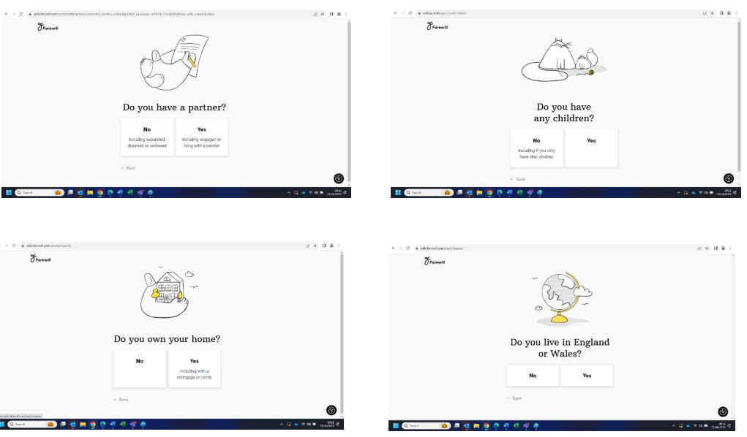
- Answer the step-by-step questions.

- Click ‘continue online’ to start making your Will.
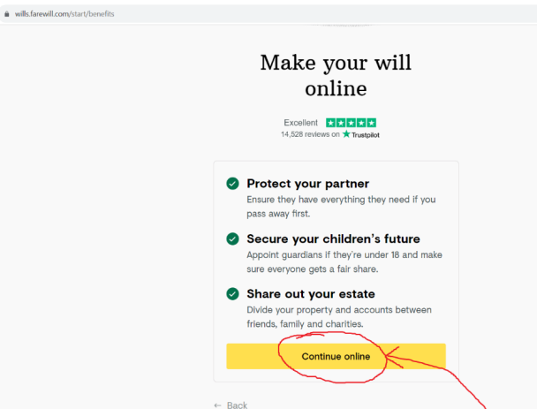

4) If you have answered that you have a partner, you will be asked if your partner also requires a Will. If you click ‘yes’ you will be able to claim both Wills for free via this Church of England scheme.
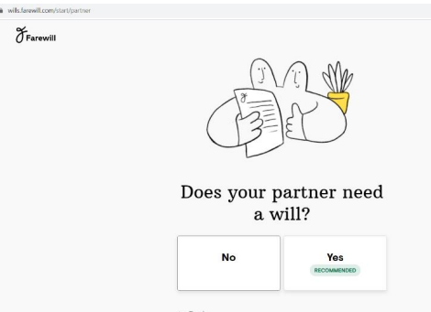
Good news – Farewill predicts it takes on average 12 minutes to complete a Will from here…

5) Fill in some basic personal details and click continue.
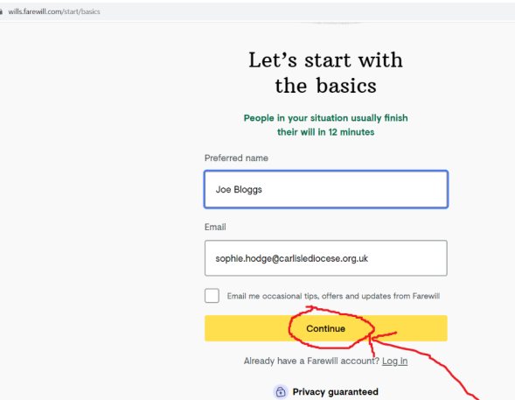

6) You will be asked to create a password. This means you can stop and finish your Will at a later date – you will just need your email address and password to sign back in.
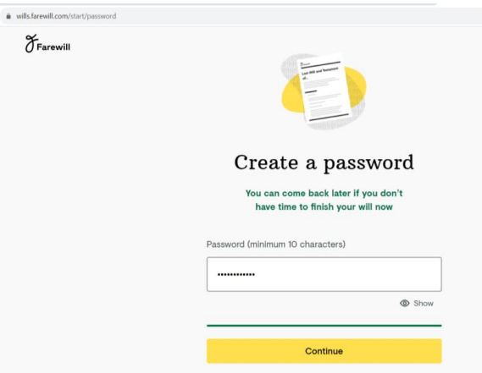
7) If you have a partner and stated that you would like them to create a Will too, filling out this screen will enable Farewill to send an invitation via email to them to start their own Will too.
If you don’t wish to do this, you can click ‘skip for now’. Your partner is also entitled to a free Farewill Will. To claim this Will they can use the Online Will Writing Service | Legal Will In 15 Minutes as it connects to the Diocese of York.
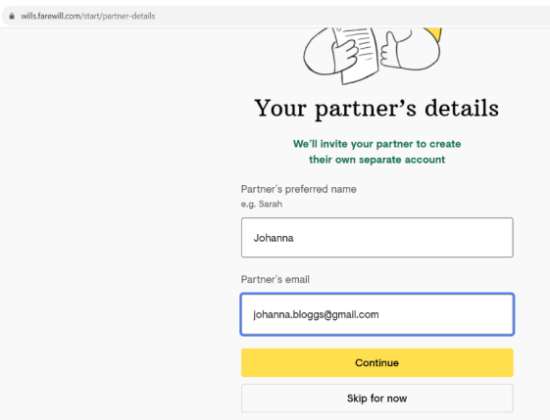

8) Farewill will ask you how you heard about this service. You may wish to select ‘through a charity’.
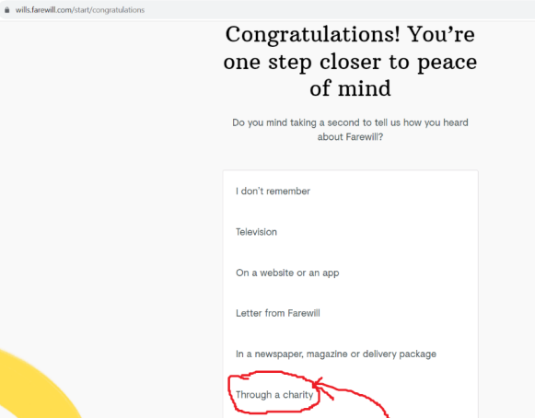

9) There are 4 steps left to completing your Will. They are:
- About you
- Accounts and Property
- Your Estate
- Executors
Farewill will take you through each of these in turn. You may wish to check you have all the information you need before you start, by referring to the ‘preassemble check list’.
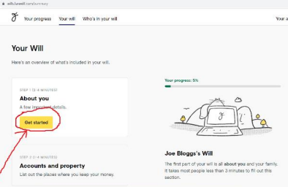
About You
Click the ‘Get started' button to begin.

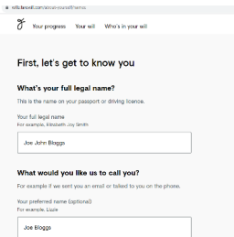
10) You will be asked for some basic
personal information including your
‘full legal name’ (as it appears on your
passport/driving license), and your
date of birth.

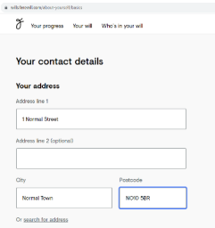
11) You will be asked for your address
and phone number (the phone
number is optional and will only be
used for Farewill to phone you to
provide support with the Will
writing). Your address should
automatically appear as you start
typing it. If you can’t find it, click
‘type manually’ to fill it in. Click ‘Save
and continue’ once you have
completed the page.

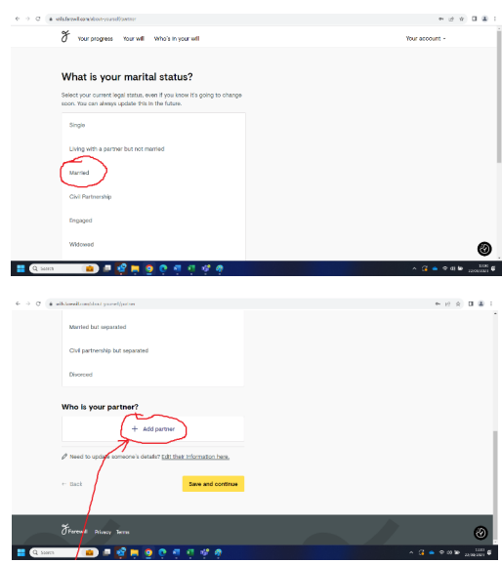
12) You will be asked for your legal
marital status. Click which ever
option applies. On the same page, if
you have a partner, you will be asked
to add your partner’s details.

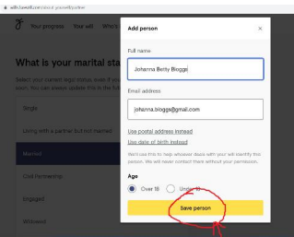

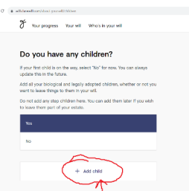
13) Next, you will be asked about any
children you might have. This
includes biological and adopted
children but not children you are
pregnant with or stepchildren. You
will have the opportunity to add
stepchildren into your Will at a later
stage.

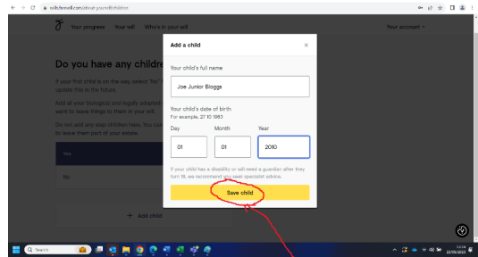

Children you are expecting will need an
update to the Will after they are born.
You can do this by opting at the check-out
to pay £10 a year for the ability to
update your Will (you can stop this
subscription at any time) or you will
need to write a new Will after the child
is born.

Once you have added all your children click ‘save and continue’.

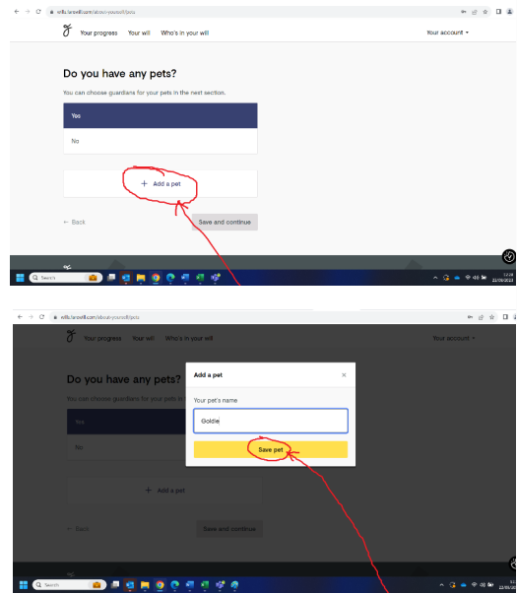
14) Next you will be able to state if you
have any pets. This is so your Will can
appoint guardians to look after your
pets after your death. Click ‘save and
continue’ once all your pets are
added.

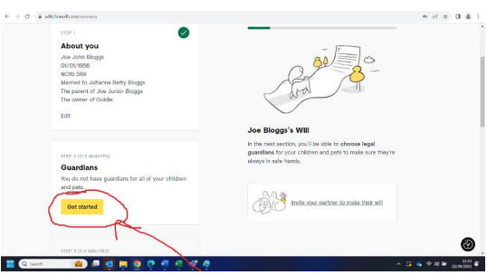
15) If you have children or pets, you will
be asked to fill out who you wish their
guardians to be after your death.

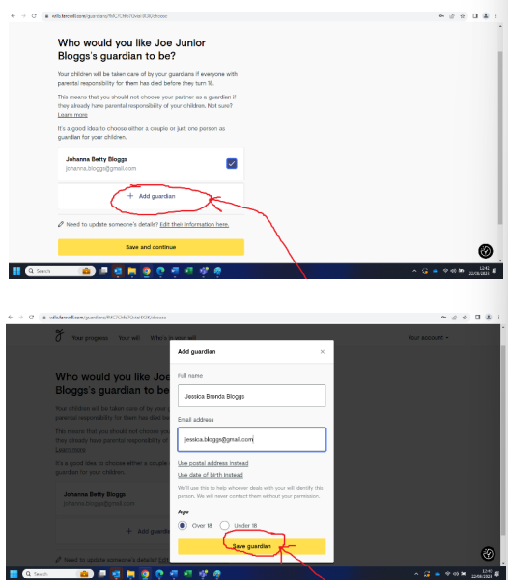
16) First you will be asked about
guardians for your children. You can
choose an individual or a couple. You
do not need to choose your partner
(assuming they also have parental
responsibility for your children) as
guardians are only appointed if both
parents die before the child reaches
18.

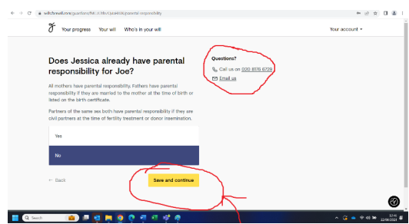

17) You will be asked if the guardian
already has parental responsibility
for the child. The answer to this
question will usually be ‘no’. If you
are in doubt phone or email the
Farewill helpline (details listed on
this page). Click ‘save and continue’.

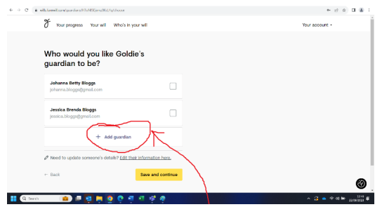
18) You will then be asked to appoint a
guardian for your pets. Click ‘save
and continue’ when you are done.

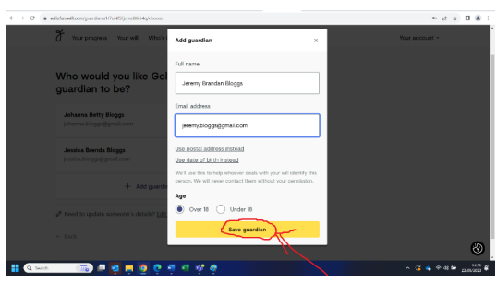

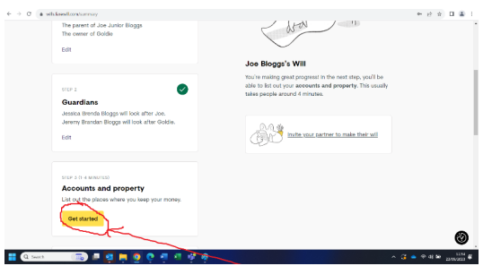
Accounts and Property
19) You will now be asked to go to
section 2: ‘Accounts and Property’.
Click ‘get started’ to begin.

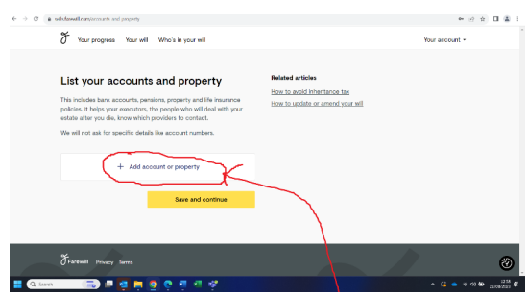
20) This is the place where you list
your bank accounts, pensions,
property and life insurance
policies. You do not need specific
details such as bank account
numbers or policy details (just the
name of the provider).
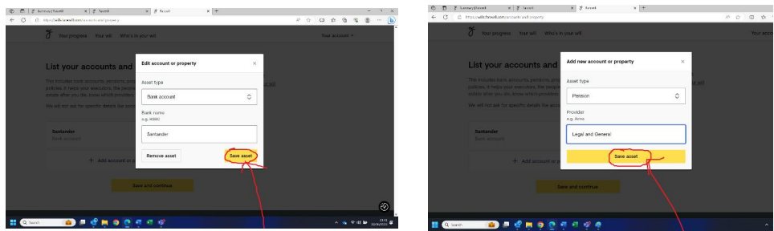
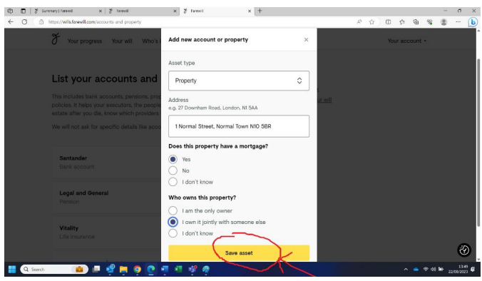

21) When you come to list any properties to own, you will be asked for a few more details such as the address, whether the property has a mortgage and whether you own the property with anyone (you do not need any mortgage details).
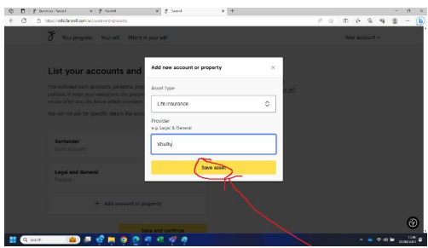

Once you have listed all your accounts and property, please click save.

Your Estate
22) In this section you will decide who inherits what you own after your death.
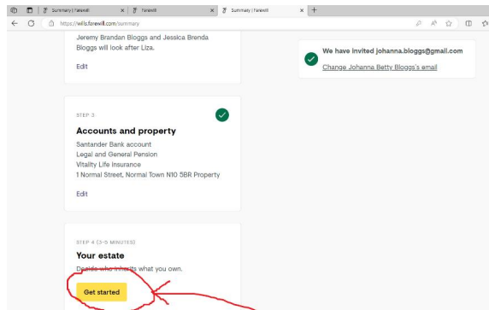

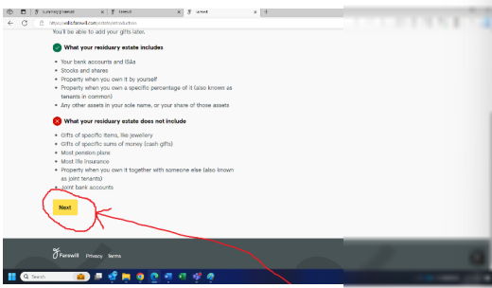
23) You will be given some basic information on what your residuary estate includes.
Once you have read the information, click ‘next’.

24) You are now able to select who you would like to benefit from your estate after your death. You can select people already mentioned in your Will (i.e. children and guardians) and add new people into your Will as beneficiaries (e.g. stepchildren, extended family and friends). To add new beneficiaries into your Will click the ‘add someone new’ button.
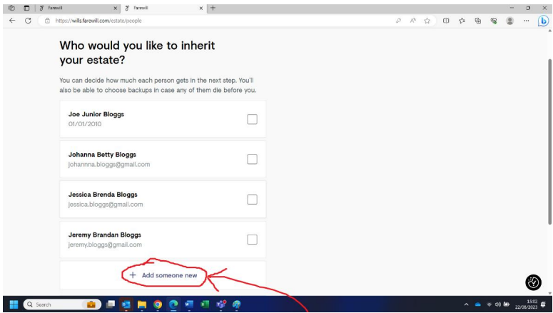
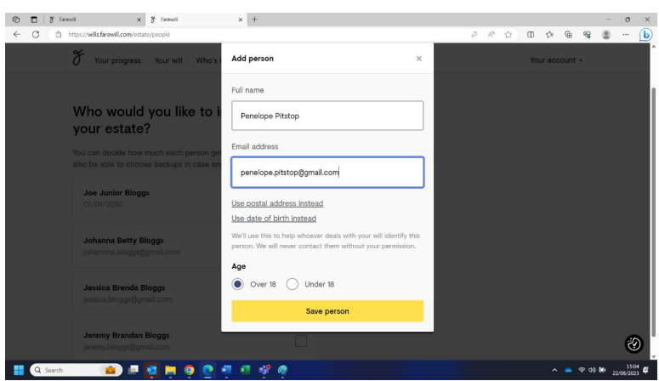
If you are married or in a civil partnership you may wish to consider leaving your entire estate to your
partner. In this scenario your estate would be entirely free of inheritance tax and your tax free
allowance would be passed onto your partner, doubling their allowance upon their death (read How
to avoid inheritance tax | 5 ways to reduce UK IHT (farewill.com) for more details). You can specify later in the Farewill process who you would like to inherit your estate if your partner was to die before
you. Your partner may wish to make a Will along the same lines.

25) Including a gift to your church. Once you have selected those who will benefit from your estate, you will be asked if you would like to include a small gift to your local church. There is no obligation to do so in order to make use of this service, but any gift you feel able to make will be gratefully received. If you select ‘yes’ you will then be able to press the ‘find our church’ button.
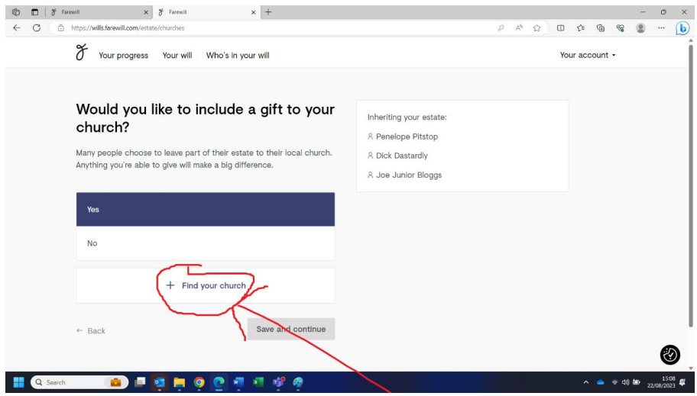

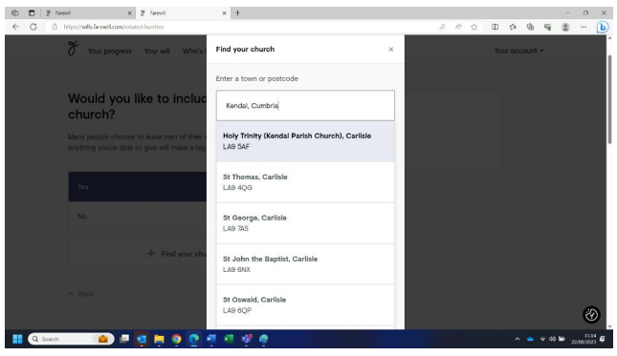
26) You will be asked to fill
in the town or postcode for your church and you will be
presented with a list of
churches, from which
you can select the right
one. Please note, all
churches have ‘York’
written after them. This
does not refer to the city of York but to the Diocese of York.
You can then confirm that the details of your church are correct by clicking ‘save church’.
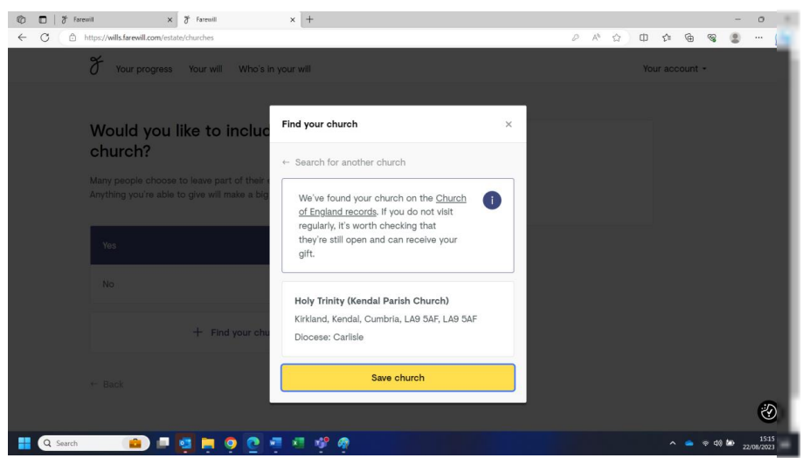

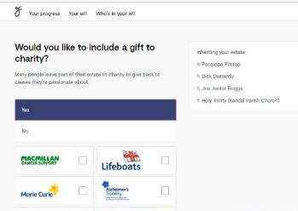
27) You will then be asked if you would like
to include a gift to a charity in your
Will. You can select from their
suggested charities or ‘add your own
charity’ if there is a particular charity
you feel passionately about.

Charities can be found by clicking the ‘add your own charity’ button and then starting to type the charity name. There is no need to know the registered charity number or any other specific details.
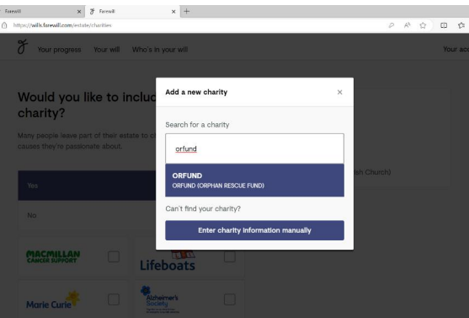

There is then an opportunity to confirm you have the right charity selected.
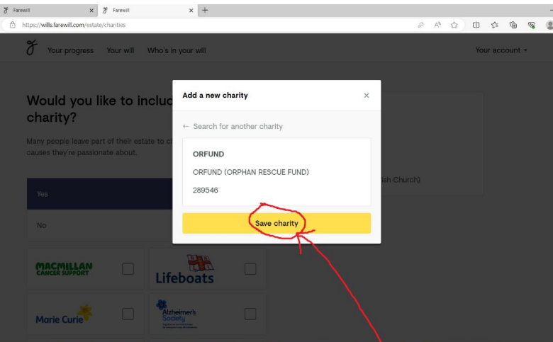

28) You are asked how you would like to divide your estate between your beneficiaries. Farewill
will make sure the totals equal 100%.
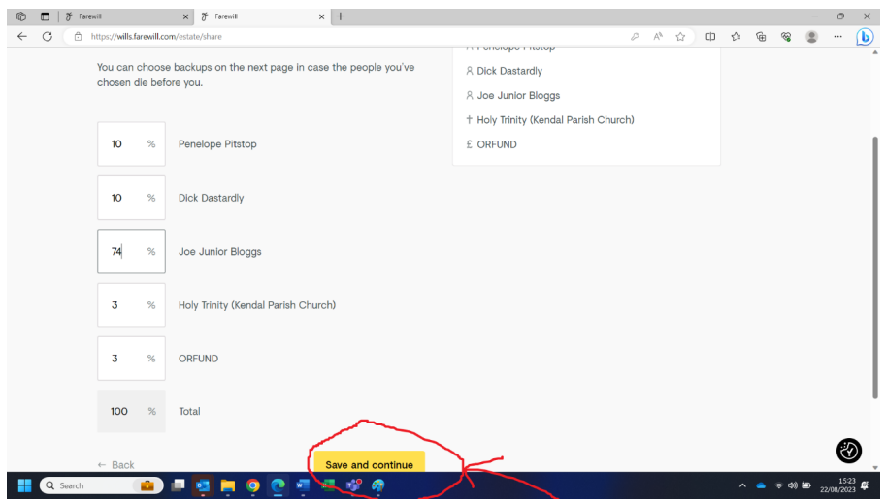

29) You will then be asked what you would like to happen if the beneficiary dies before you. You could select their children to be the new beneficiary(ies); a different person, church or charity to become the beneficiary; or for their share to be split between the remaining beneficiaries.
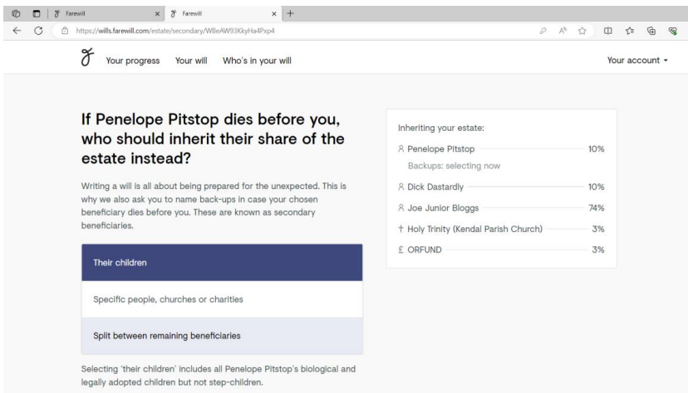

30) Finally, you will be asked if there is anyone you are specifically choosing to leave out of your Will. You will have the opportunity to explain your reasons in a text box, which could be important if anyone ever challenges the Will. No one will see this information other than the executor.
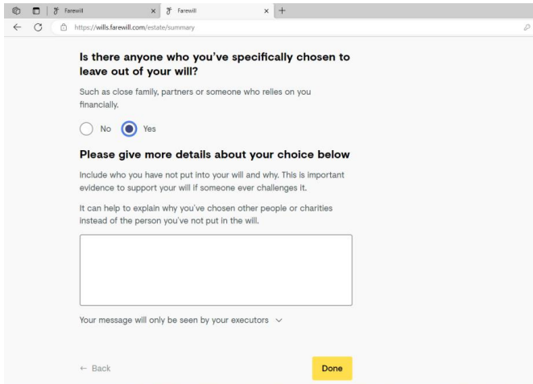
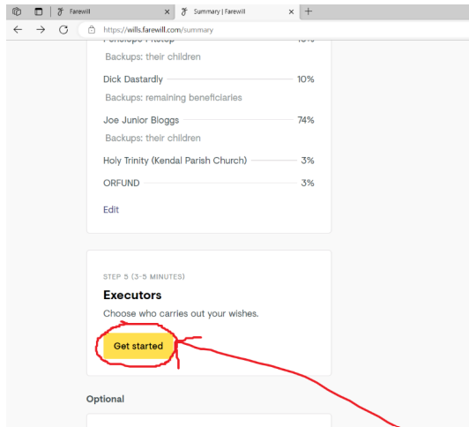
Executors
31) To start this fourth and final section click ‘get started’:

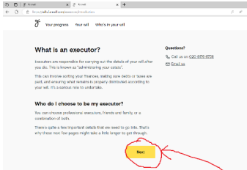
There is a brief information page explaining what
an executor is. Once you have read it click ‘next’.
There is then another information page outlining
typical fees for a professional executor. Once you have read the information click ‘Next, choose executors’.

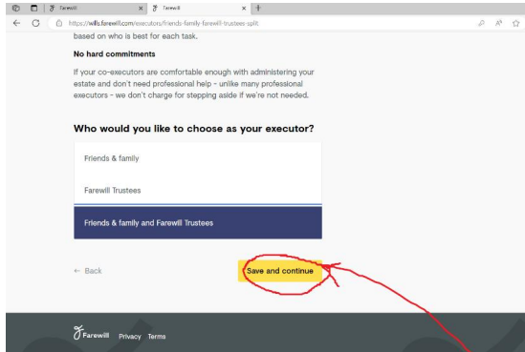
32) You are then asked to select the type of executor you would like to select, e.g. friends & family or Farewill Trustee. If you would like to use a solicitor as your executor you will need to select ‘Friends & Family’. Either your friends or family can then instruct a solicitor upon your death, or you can put solicitor details into the friends & family section.

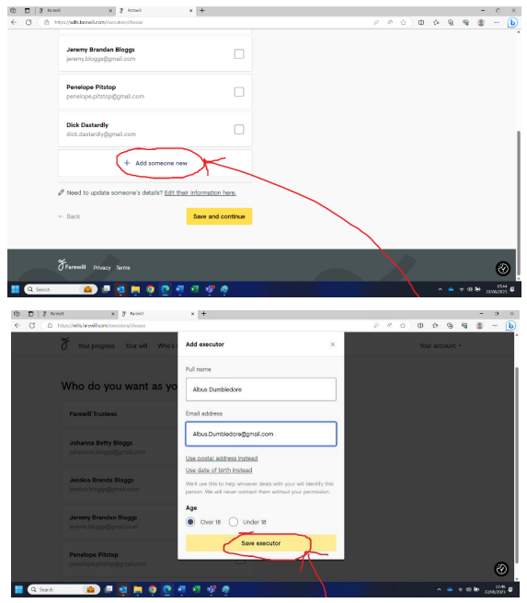
33) If choosing friends/family to be your
executors, you will again have the
opportunity to add their name onto
Farewill if they are not there already.

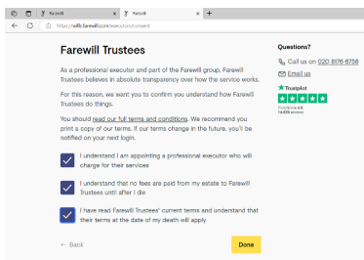
34) If you have opted to use Farewill
Trustees as executors, you will be asked
to confirm you have understood some
terms and conditions.

WELL DONE! You have completed your Will. You can either finish the process by clicking ‘Purchase and send for checking’ or you can choose to add in some optional extras.

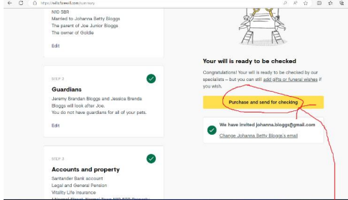

OR
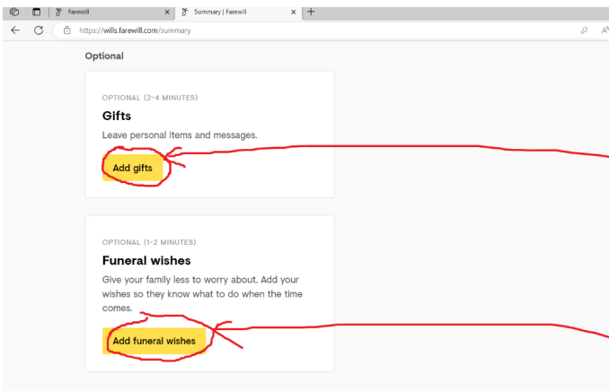
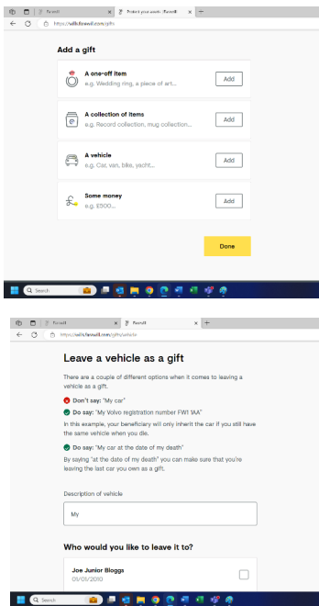
35) Leaving Gifts. You will be asked
what type of gift you would like to
leave, and to whom you would
like to leave it. E.g. a one off item
such as jewellery or a piece of art,
a collection of items, a vehicle or a
sum of money. You will have the
opportunity to describe the item
in as much detail as possible to
avoid confusion and you can
include a message to the
beneficiary explaining why you are
leaving them the gift. You will also
have the option to add new people
as beneficiaries at this point.

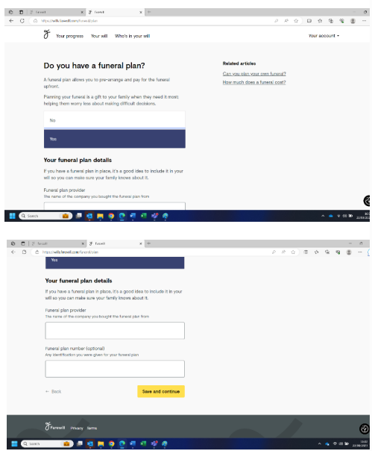
36) If you have a funeral plan, it is very
helpful to include the details in your Will.

37) If you don’t have a ‘funeral plan’ you still have the option to share details of your funeral
wishes. This isn’t legally binding but can help family with making difficult decisions.
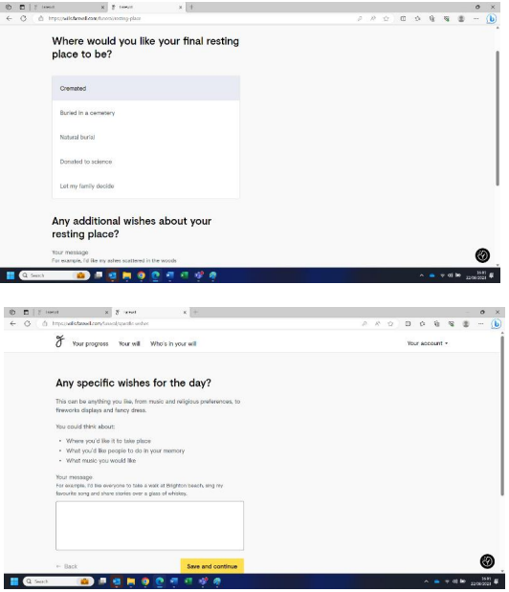

WELL DONE on getting this far. You have now completed your Will. Please select the ‘purchase and send for checking’ button to complete your Will (you will not be charged).

