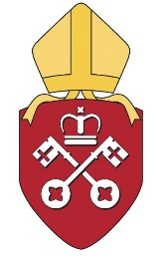
York Diocese: Lifelong Learning
Supporting mission and ministry across the diocese of York

Application for CMD Grant

These grants are awarded from your personal CMD grant, subject to the amount you have available, the agreement of the Adviser and completion of an Evaluation form for previous grants.

NAME:
EMAIL ADDRESS:
BENEFICE
POST:
EVENT FOR WHICH FUNDING IS SOUGHT (please provide details such as time and place of event):
OTHER BODIES PROVIDING FUNDING & AMOUNT:
PLEASE SUMMARISE THE WAYS IN WHICH YOU ENVISAGE THE PROPOSED TRAINING EVENT/ COURSE OF STUDY WILL HELP YOUR DEVELOPMENT AND MINISTRY:
AMOUNT REQUESTED FROM THE DIOCESE: | £  (please be aware that CMD grants cannot be used to cover travel costs)
TO WHOM SHOULD THIS BE PAID?
To you (external events)/ Diocese (internal events) Please delete as appropriate.

SIGNED: DATE:

Please attach a letter, invoice or statement which includes full costs and details for the event for which you are applying and download a CMD Evaluation form to complete and return when you have attended the event for which you have applied for a grant.

When complete please submit to training@yorkdiocese.org. You application will be considered at the next CMD Grants Panel meeting, following which we will advise you of the Panel’s decision.

